

Business Requirements Document (BRD)

|  |  |
| --- | --- |
| Project Name | Billing Operations |
| Date | 8/21/2017 |
| Business Owner | Norm Chan |
| BSA | Martin Iwanicki |
| Version | 1.0 |

1. **Introduction**
   1. **Project Background**

The Billing Operations module is used for customers that wish to pay invoices in installments. The Billing Team will setup sales order with the correct billing schedule based on agreement sales reps made with customers. Some customers are getting confused when the instalment invoices are sent out, and disputing payment because of the invoice format.

PlanGrid provides a Service Start and End Date that shows the terms of the service. Customers that forget installment payments will look at this date on the first invoice sent, and assume invoice was paid in full. The only difference on each invoice is the amount. There is no way for the customer to identify which invoice is sent as part of the billing schedule.

Customer should be able to know what invoice they are receiving (1 out of 3). Also, the service Start and End dates should match the billing schedule. This will help keep the invoice aligned with the installment schedule agreed upon.

**1.2 Main Benefits**

* Enhancements to the invoice will reduce customer disputes and improve collections on invoices setup with installment payments.

**1.3**.    **Acronyms, Abbreviations and Definitions**

**Service Start and End Date**- Plangrid custom field to determine length of subscription services.

1. **Business Process**
   1. **Current Process**

* SFDC opportunity has Installment Payment field set to true by sales rep or billing team prior to syncing to Netsuite.
* Billing will sync SFDC opportunity to create Netsuite Sales Order in Pending Approval state.
* Billing schedule will be added to the line items that have been agreed upon with the customer
* First Invoice will be sent once billing schedule has been added by manually clicking the Next Bill button on the sales order.
* Future invoices are sorted and created from Invoice Sales Orders Suitelet.
* Invoice created is sent to customer through custom dunning workflows daily at 7 PM.
  1. **Process Flows**
     1. **Current Process**

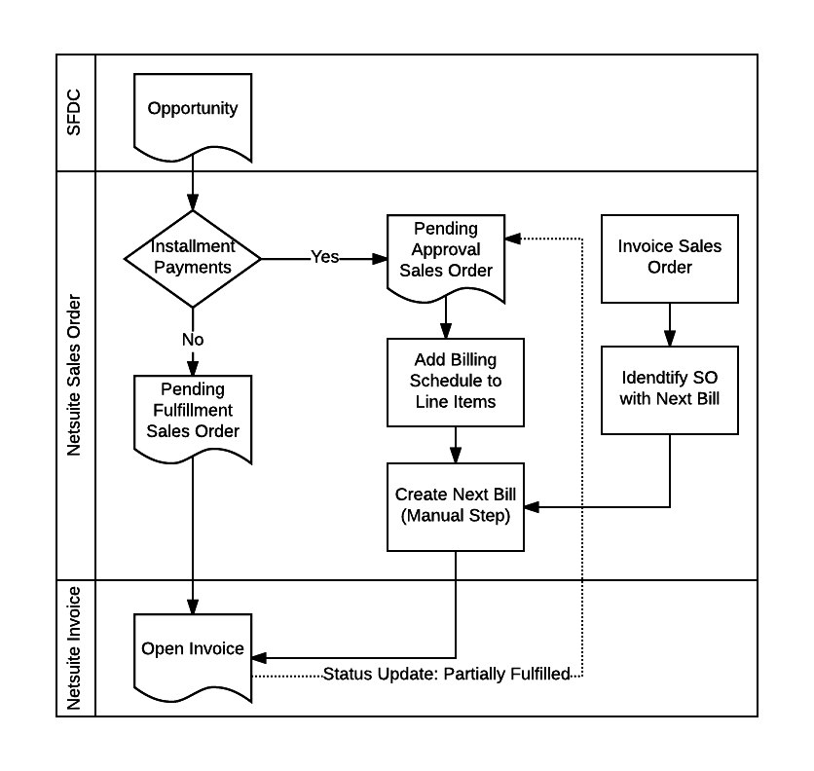

**2.2.2 Future Process**

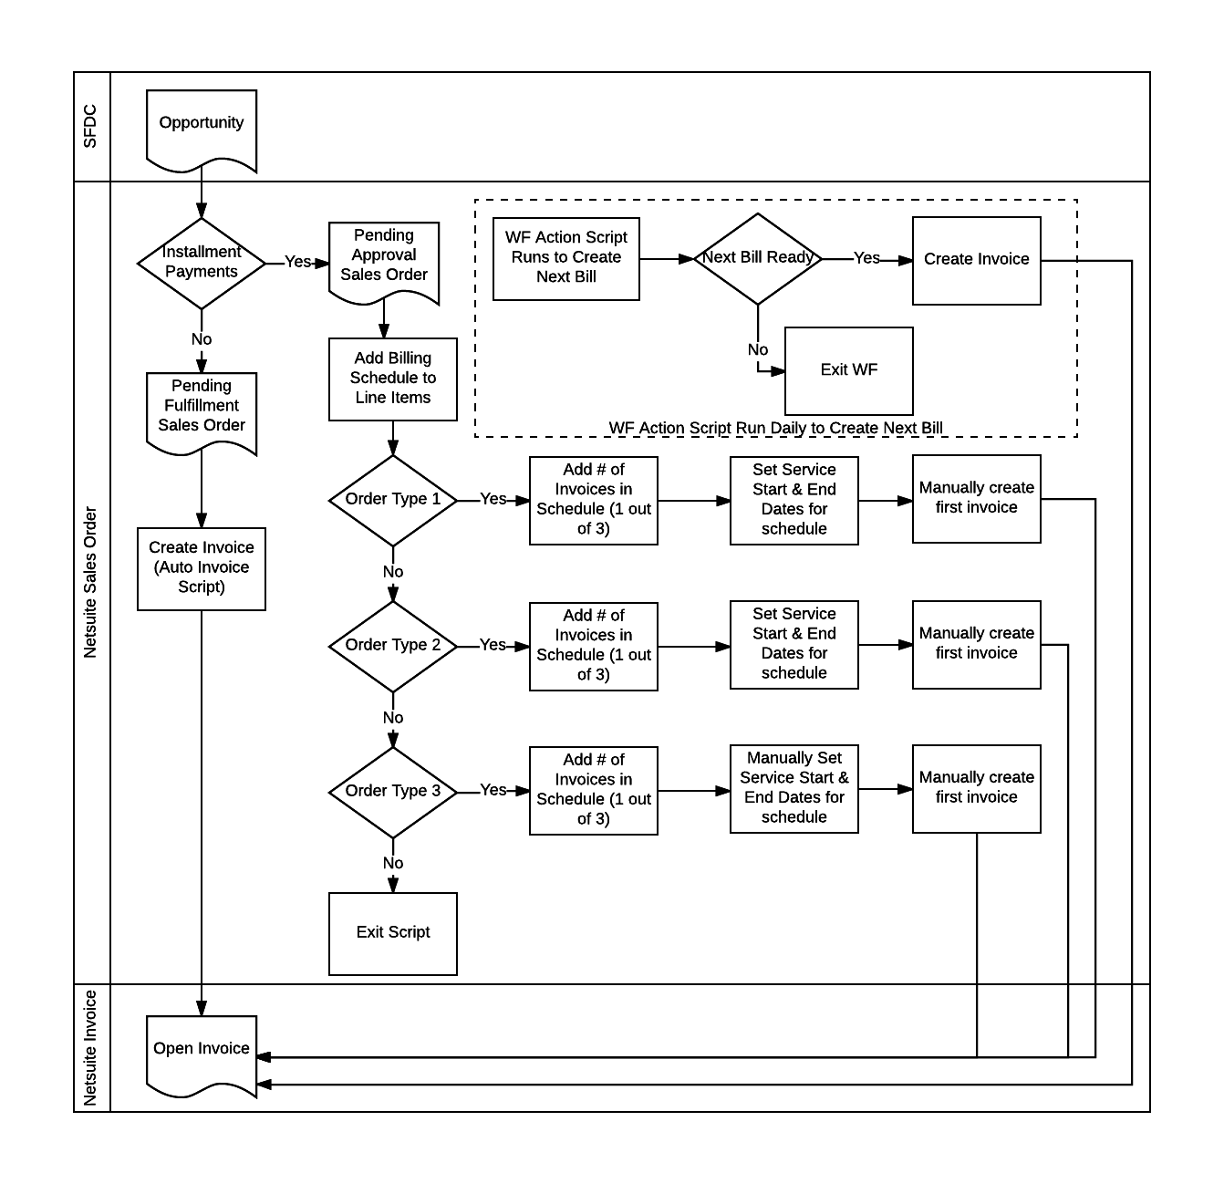

1. **Business Requirements Overview**
   1. **Requirements**

* **Custom Fields** will be present on the sales order and invoice to capture the number of invoices (Invoice # 1 of 3) in the schedule, along with service start and end dates at the header level. Invoice will source these fields when record is created.
* **Script 1** will run when Installment Payments is set to true, and a billing schedule has been added to the sales order line items. When the record is saved, the script should run to add the number of invoices in the schedule, and the service start and end dates based on the billing schedule at the header level.
* **Script 2** will run after the invoice has been created, Installment Payments is set to true, and a billing schedule is present on the invoice line items. The service start and end dates on the sales order will be added to each of the line items on the invoice, matching the billing schedule service dates.
* **Workflow Action** will run daily to create invoices for Order Type 1 and Order Type 2 sales orders when billing schedule is added during booking process. Order Type 3 will have all invoices created manually to make sure custom start and end dates are captured correctly.

**3.2 User Stories**

**Order Type 1:** Standard sales order created with each line item having the same service start and end date. Billings will add or create custom billing schedule to each line item that will be billed in installments. Script should run once the sales order is saved to add number of invoices in schedule, add Start and End dates matching the billing schedule. The billing team will then click Next Bill to create the first invoice. All line items on the invoice should have the matching service start and end dates from the sales order. Workflow Action will run daily to create future invoices based on the billing schedule.

**Order Type 2:**  Co-termed sales order created that can have different start dates for each line item, but the same end dates. Billings will add or create custom billing schedule to each line item that will be billed in installments. Script should run once the sales order is saved to add number of invoices in schedule, add co-termed Start date and matching End date for first invoice, then matching Start and End dates for remaining invoices. Billing team will then click Next Bill to create the first invoice. 1st invoice will use co-term Start and matching end dates. Workflow action will run daily to create future sales orders based on the billing schedule.

**Order Type 3:** Consolidated sales order with line items that all may have different service start and end dates. Billings will add or create custom billing schedule to each line item that will be billed in installments. Script should run once the sales order is saved to add number of invoices in schedule. Billings will enter service start and end dates manually, and then click Next Bill to create first invoice. All future bills will be created manually to ensure the varying services start and end dates match the billing schedule.

1. **Open Topics for discussion**

* Final solution to be confirmed after Netsuite technical resources have reviewed the business requirements.

1. **Acceptance**

The project team is in agreement that the requirements documented above are accurate and representative of the company’s business needs for this project. This document will act as the basis for all subsequent implementation activities.

|  |  |  |
| --- | --- | --- |
| Name | Role | Approval Date |
|  |  |  |
|  |  |  |
|  |  |  |

* Expected Start and End date will come from the SFDC opp and be mapped to the SO header level
* Billing Cycle indicting the subscription term (Annual, Bi-Annual(Need to add value in SFDC),Quarterly, Other) will be mapped to NS SO at the header level